Theories on the Value of Art

Below details a series of views on the value of art. The typical debate has been on what, if any, unique and single value art has, or, what makes good art good - there are variants of this, however.

1 Aesthetic Hedonism
The view that the value of art comes from the pleasure it gives us. (e.g. Mohan Matthen)
- Art makes us feel good - and that’s good

2 Aesthetic Expressivism
The view that the value of art has to do with emotion - artists expressing emotion and/or audiences experiencing emotion. (e.g. Jenefer Robinson. Links to Collingwood)
- Art makes us feel - and that’s good

3 Aesthetic Cognitivism
The view that the value of art is in the understanding it gives us. Typically thought to be some kind of understanding that can’t be gained by other means. (e.g. Gordon Graham, Noel Carroll)
E.g. about life, love, human nature etc.
- Art makes gives us understanding - and that’s good

4 Formal Value
Focus on formal aspects of a work of art (traditional approach) (Links to Kant).
- Art gives us aesthetic qualities, which are good

5 Moral Value
The view that art gives us moral value. Sometimes a kind of aesthetic cognitivism, (i.e. art gives us moral knowledge). Less common with visual arts but relates to aesthetic moralism - i.e. art is less valuable when it is unethical (e.g. Matthew Kieran, Noel Carroll. Also links to Plato).
- Art makes us better people - and that’s good

6 Social Value
The view that art performs some social function (for good). E.g. bringing people together, communicating, etc. (e.g. Vid Simoniti, David Davies), shared experience (e.g. John Dewey)
- Art performs some important function socially

7 Political Value
Relates to social value - the view that art can have impact on political goals (could be subsumed under social value?). Not necessarily the sole value of art. (e.g. Vid Simoniti)
- Art furthers (our) political aims

8 Valuing of art Processes
Artistic practices bring us some value - value of doing art (process rather than product). Various possibilities - e.g. art brings us creative stimulation, an outlet, purpose, etc.
- Doing art give us X - and that is good.

9 Valuing Artistic Achievement
Good art is an achievement. Relates again to the practice of art - skill. Directly relates to possibly what AI doesn’t provide (i.e. using AI means the artwork is less of an achievement) (e.g. James Grant)
- Good art is an achievement

10 Aesthetic Pluralism
Relates to the cluster account of art. (e.g. Berys Gaut)
- Art can give us various things of value (not only one)

Multiple values - (Gaut’s view) [Possibility that we can also pull out these - and see whether people agree]
- Possessing positive aesthetic properties (formalism)
- Being expressive of emotion (expressivism)
- Being intellectually challenging (cognitivism)
- Being formally complex and coherent (formalism)
- Having the capacity to convey complex meaning (cognitivism/social)
- Exhibiting an individual POV (social)
- Being an exercise of creative imagination (creativity/process/achievement?)
- Being the product of a high degree of skill (achievement)
- Belonging to an established artistic form (definitional - likely not to do with value at all)
- Being the product of an intention to make a work of art (definitional - likely not to do with value at all, but does link to process)

My summary of whether I think AI can or cannot achieve cluster properties (from “AI and the Cluster Account of Art”, 2024).

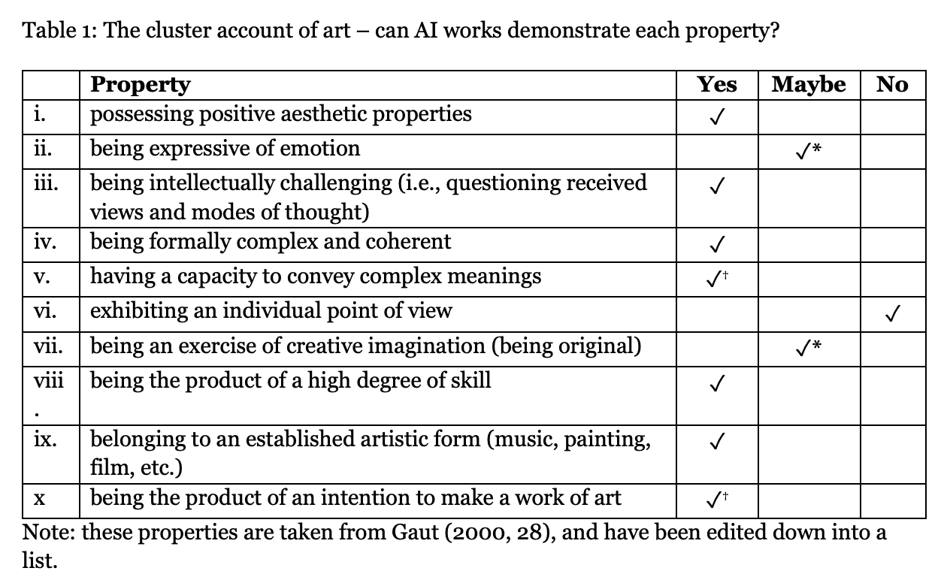

For further info:

- IEP: https://iep.utm.edu/value-of-art/
(Note - Drummond’s summary of relevant theories is different to my own - I take him to be talking more about the nuances of aesthetic and artistic value in many of these. I follow Graham’s approach).

- Intro to Aesthetics: https://www.routledge.com/Philosophy-of-the-Arts-An-Introduction-to-Aesthetics/Graham/p/book/9780415349796

- SEP: https://plato.stanford.edu/archives/fall2024/entries/art-definition/

